NASHVILLE STRIDERS ANNOUNCE PETER PRESSMAN SCHOLARSHIP WINNERS FOR 2019 – 2020
Jerry Marcec

The Nashville Striders Board of Directors is pleased to announce that Christopher Caruso and Alex Ponce are the winners of our 2019-2020 Peter Pressman college scholarships. Congratulations! We offer earnest thanks to all the students who applied for the scholarships we had to offer. We appreciate all the students and their families taking the time to apply and to support the Nashville Striders. The Board named the scholarship program for Peter shortly after his death in March of 2018. For the first time for the 2019-2020 school year, we made undergraduate students as well as high school seniors eligible for these scholarships. No current college undergraduate students applied. A maximum of four $1000.00 were available to high school seniors and undergraduates.

Christopher and Alex were at our May Striders Board of Directors meeting to receive their awards. Ruth Pressman, Peter’s wife, presented the certificates to Christopher and Alex.
Their $1,000.00 awards will be sent to the bursars of their respective schools for application to their student accounts.

Christopher Caruso graduated from Ravenwood High School in Brentwood on May 25th. He is enrolled at the University of Tennessee at Chattanooga and plans to major in computer engineering. Some of Christopher’s recent extracurricular activities include Speak Club (founder and president), National Mathematics Honor Society (Mu Alpha Theta), National Honor Society, National Technical Honor Society, Ravenwood Cultural Heritage Society, Ravenwood Coding Club, ACE Mentoring Program and Ravenwood Computational Linguistics.

Christopher ran 4 years of high school cross country at Ravenwood. He plans to run local races around Chattanooga from 5K to half marathon and will volunteer at others. As time allows, he will travel with his father to half marathons with the goal of running at least one half marathon in each of the 50 states. Christopher will also participate in Nashville Striders events when he is home for holidays.

In his essay Christopher says “As someone with Autism Spectrum Disorder (ASD), running has been especially important to me. While I can show you how to work your iPhone, computer, or just about any other piece of technology in a flash, simply relating to others and carrying on a conversation can be challenging. Fortunately, running has allowed me to join in with others.”

One of Christopher’s reference letters declares “What strikes me about Christopher goes beyond his running successes and academic achievements. It is his clear understanding of his future goals. I feel that this is what provides him with a strong foundation to excel in college.”

Christopher also states in his essay “I believe that I can achieve my goals. Just as I aim to consistently do my best in running, I have learned self-discipline and gained the desire to become a better person, a better athlete, and a better student day by day. If I had never taken up running, then I would never have met the people I have met, accomplished the things that I have, and taken up the hobbies I enjoy today. Without running, I would simply be another socially isolated youth with ASD.”

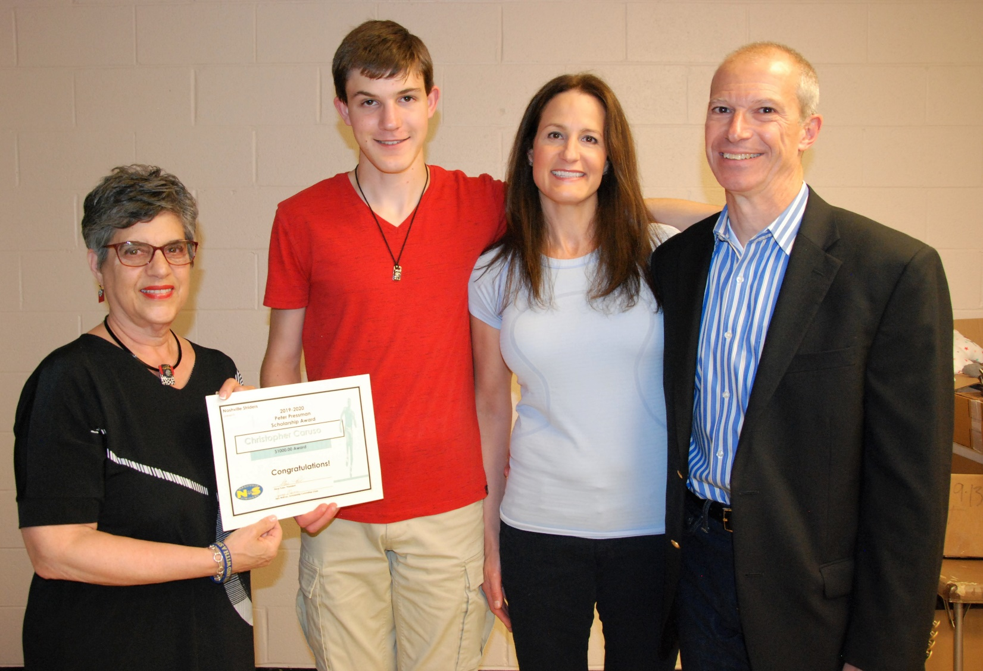
Ruth Pressman, Christopher and His Parents

Alex Ponce graduated from Merrol Hyde Magnet School in Hendersonville on May 18th. He is enrolled in the University of Alabama in Huntsville and plans to major in chemistry. Some of Alex’s recent extracurricular activities are National League of Junior Cotillions Sumner Chapter (Head Teen assistant), Boy Scouts of America (Eagle Scout), National Honor Society (Treasurer), Merrol Hyde Academic Team, and Merrol Hyde History Bowl Team.

Alex ran cross country and track at Merrol Hyde, each for 6 years. He has been a member of the Nashville Striders for several years and runs in Strider’s events. He is signed to compete in indoor and outdoor track and field as well as cross country for the University of Alabama in Huntsville. He has been accepted to their Honors College and through the Honors College will participate in undergraduate research projects. Alex plans to continue serving his community by joining outreach programs. He wants to become a pharmacist so he can create new medicines and save lives.

In his essay Alex writes “The feeling of running is one of freedom. It is simply the runner and the path before them. It is freeing to feel the earth beneath your feet and to be propelled by your own body rather than a car or bike. Running has helped me realize the simplicity of joy despite the many worldly distractions of modern day life.”

In one of Alex’s reference letters a coach says “Alex embodies all of the qualities the scholarship committee is looking for. He is a very accomplished runner who has set state records, fought for individual high school state championships and set numerous school records. However, I feel his greatest running accomplishment is the amount of time and attention he gives to the younger runners on his team.”

Alex concludes his essay by stating, in part “I plan to take all that I have learned from running, the moral lessons and training, and put it to use in college. True joy comes from setting out to do something and doing it because it gives the individual a sense of accomplishment and tells them that anything is possible with the right mindset and training. That sense of success is what I hope to cultivate when I run in college and beyond.”

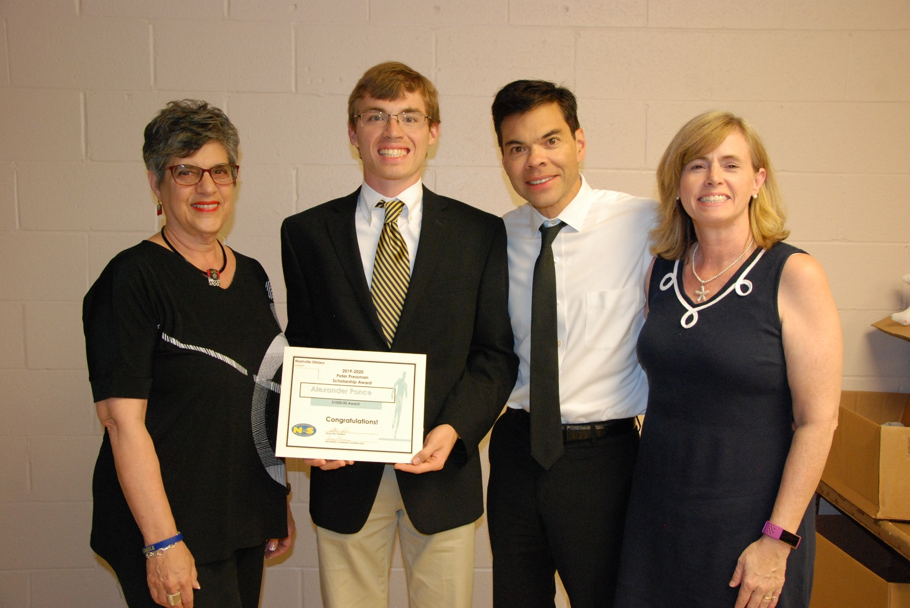

Ruth Pressman, Alex and His Parents

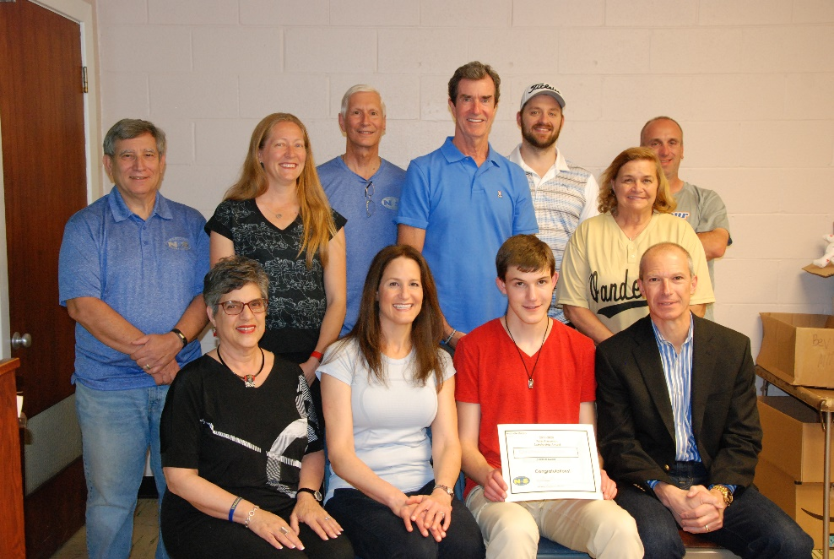

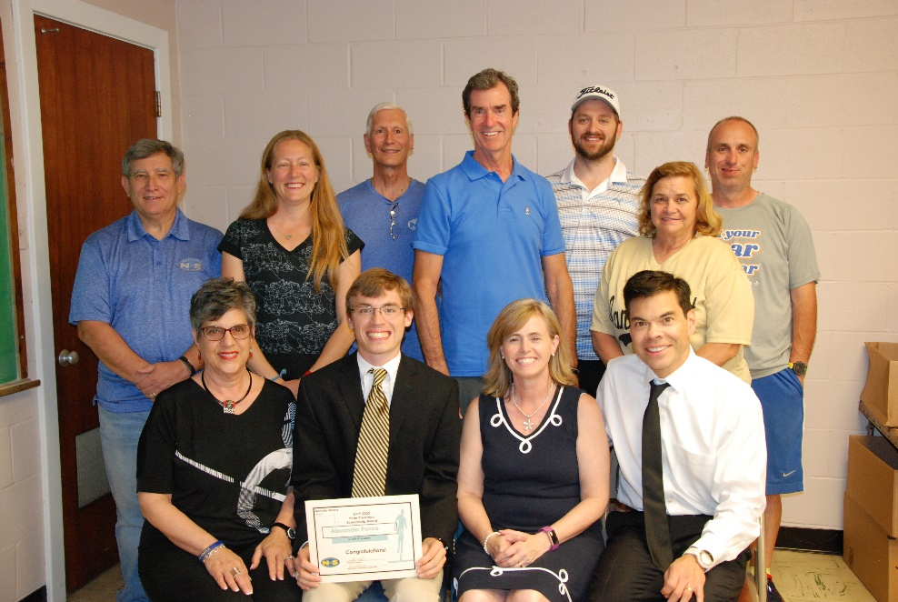
Striders Board Members, Ruth Pressman and Our Scholarship Winners with Their Parents

This is the fourth year that the Nashville Striders Board of Directors has provided college scholarships as an addition to our list of member benefits. At the April Board of Directors meeting the scholarship committee recommended these candidates to the Board and they endorsed them as scholarship winners. We plan to offer similar opportunities next year. Scholarship application forms for the 2020-2021 school year will be available next January on the Nashville Strider website. For more information, click the following link: http://www.nashvillestriders.com/scholarship/

More about the Peter Pressman Scholarship Program - Current high school seniors and undergraduate students can apply for the 2020 - 2021 scholarship between January 15 and March 15, 2020. Applicants must be graduating High School seniors seeking to further their education at a university, college or technical school or full time undergraduate students at a university, college or technical school.

To be eligible applicants must:
- Be an Individual or Family member of Nashville Striders in good standing for at least one calendar year or
- Be a student of parents or legal guardians who are members in good standing for at least one calendar year.
- Submit a complete application with a signed endorsement by a parent or legal guardian.
- Be a graduating High School senior or an undergraduate student (at least 12 semester hours).
- Provide evidence of involvement in or commitment to running/walking related activities.
- Supply letters of recommendation or reference from coach, teacher, trainer or someone familiar with you and your running/walking activities involvement or commitment.
- Submit an application and all related documents to Nashville Striders Scholarship Committee during enrollment period January 15th through March 15th for the upcoming school year. All application materials must be received by the Nashville Striders by March 15th.

EVALUATION CRITERIA (no particular priority):
- Satisfactory academic achievement to be judged by Nashville Striders Scholarship Committee
- Essay content
- Extent of volunteer participation in Nashville Striders events
- Coach’s and references’ recommendations
- Participation in running/walking related activities
- Participation in other extracurricular activities
- Consideration to first time applicant(s)
- Involvement in an interview may be requested at the discretion of the Scholarship Committee

For more information, go the Nashville Striders web site. http://www.nashvillestriders.com/scholarship/

If you have questions, please contact Jerry Marcec, Peggy Stanfield or Bill Cohen or send an email to stridersscholarship@gmail.com.

